Staying Connected via ICTs

1. Define ICT: _______________________________________________
2. What are some ways that people connected with family and friends in the past? ________________________________________________________________________________________________________________________________________________________________________________
3. Mobile phones: Record 3 key pieces of information

* ________________________________________________________________________________________
* ________________________________________________________________________________________
* ________________________________________________________________________________________

1. The Internet: Record 3 key pieces of information

* ________________________________________________________________________________________
* ________________________________________________________________________________________
* ________________________________________________________________________________________

1. Define ‘Social Media’ ________________________________________________________________________________________________________________________________________________________________________________
2. Define ‘Virtual Community’ and provide one example

________________________________________________________________________________________________________________________________________________________________________________

1. List some of the effects of social media

|  |  |
| --- | --- |
| **Positive** | **Negative** |
|  |  |

1. Outline the impact of new technologies on the way that people ‘work’.

________________________________________________________________________________________________________________________________________________________________________________________________________________________________________________________________________________________________________________________________________________________________

1. Define ‘E-Commerce’: ______________________________________________________________________
2. Identify the top 3 categories of online expenditure:
3. _______________________________________
4. _______________________________________
5. _______________________________________

Case Study: Online Gaming

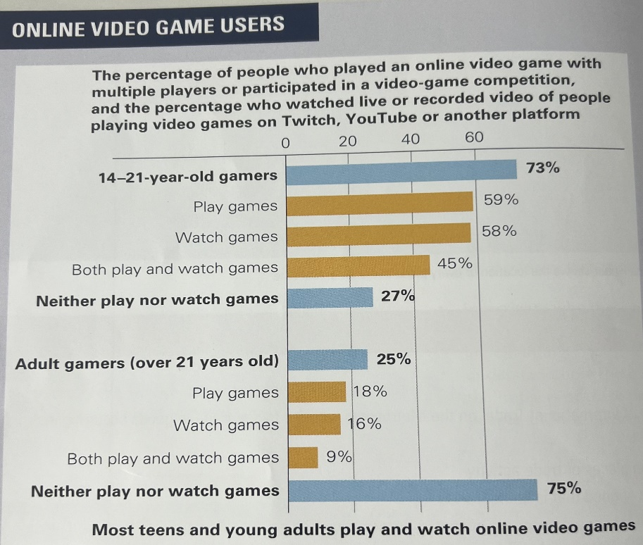The fact that more teens and young adults are connecting to each other online can also change the way people feel about places and how they use spaces. For teenagers in the past, the bedroom was a place to retreat from the world. However, today it may have a different meaning. It can be a ‘portal’ to an online community, where people interconnect on an international scale via platforms such as YouTube, Twitch and Tik Tok.

Based on the graph, is playing video games a positive or negative influence on teens? Use evidence.

What is the difference between 14-21 year old gamers and adult gamers? Use evidence.

What percentage of teens have met an online friend in person? _________

What percentage of teens have made *more than 1* friend online? ___________________

Ask your peers about their online use. What do they use their phones for and how much time do they spend?